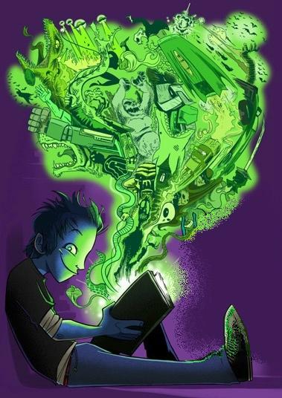

Image source: Created by the Centre for Youth Literature, State Library of Victoria,
in partnership with the Department of Education and early Childhood Development. 2009.

WIRED Year 9 2020

Name: ……………………

Class: ……

Reader Profile

1. How do you rate yourself as a reader? /10

Term 1 Term 4

2. Why do you think that is?

3.How often do you read? Tick
I read every night and at other times if possible
I read at least once a day
I read about once or twice a week
I read about once or twice a fortnight
I only read when I have to

4. What is the best book/s you have ever read?
Term 1 Term 4
Interview with English Teacher
Notes: Date:  Reading Goal: | Notes: Date:  Reading Goal:
WIRED.5 score: | WIRED.5 score:

Reading Log

Author | Title | Month  Started | Not Finished | Finished | Your Rating
Kinney | Diary of a Wimpy Kid | Feb 12th | Page 22 |  | 2/5
Arena | Specky McGee | March 20th |  | April 10th | 5/5

Reading Log

Author | Title | Month  Started | Not Finished | Finished | Your Rating

Reading Challenges (5 101520 – points)
Historical Fiction | ODT – interview | Reading Goals | 10min timed read
First Book of a Series | Horror | Stand-alone fiction | Use a WIRED poster to help you select a book.
Non-fiction matched with a fiction | War Story | Dystopian | Read a book that you have found a trailer for or that is a movie.
Out of this world | Set in another country | Realistic Fiction | Online magazine or ebook
Read a book with a mate | A book a classmate recommended | 2nd Book of a Series (must have read Bk. 1) | Create a photographic collage of your favourite character
Reader Profile Survey | Create a recorded review of the book you just read to play to the class.  (1m minimum) | VPRC Completed | Read at home >3 times a week for 4 weeks with parent’s signature.

Reading Challenges – How they work

- Each challenge carries points
- Points are awarded once verified by teacher or librarian’s signature (they will sign over the completed box)
- Provide the name of the book
- Fill out other information if required
- At the end of each term, points will be tallied for each class
- Prizes may be awarded (To Be Decided) termly, per semester and then at the end of the year.
- These booklets are collected and kept by your English Teacher
- Complete the points tally below each time you complete a challenge

0

